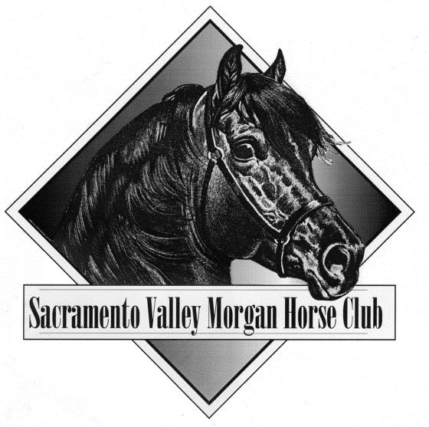

47th Annual MOTHER LODE HORSE SHOW
August 29th to September 1st 2024, Rancho Murieta CA
*with more open divisions!

EVENT AND ACTIVITY SPONSORSHIPS:

FRIDAY COFFEE DONUTS

SATURDAY COFFEE DONUTS

SUNDAY COFFEE DONUTS
- THURSDAY BARN PARTY
- FOR THE KIDS (SUNDAE BAR, SNOWCONE BUS, FLOAT DRINGS)
- SATURDAY EVENING FOOD/GOODIES/DRINGS
- OTHER ____________________________________________________________

AWARDS AND CLASS SPONSORSHIP:

Money Championship - $175

Non-Money Championship - $100

Regular Class - $60

Name Address City/State/Zip Telephone Email
Preference: Circle choices Western Pleasure Carriage Hunter Pleasure Reining
Trail Junior Exhibitor
Dressage Classic Saddle/Drive
In-Hand Opportunity Western Dressage Sport Horse Halter
Park Harness/Saddle
Working Hunter English Pleasure Driving
Other ________

!!!Your sponsorship will be posted on the club website, announced at the show and included in a hand out at the show!!! BANNERS WECOME!!!

Make check out to SVMHC and return to:
SVMHC – c/o Carol Martin, 1332 Zandonella Rd.,
Diamond Springs, CA 95619
svmhcmail@gmail.com
www.svmhc.com

